Module 18) React.js for Full Stack

=> Introduction to React.js
Q.1: What is React.js? How is it different from other JavaScript frameworks and libraries?
Ans:
- What is React.js: React is a open-source JavaScript library for building user interfaces. React is used to build single-page applications.

React allow us to create reusable UI components. React is a front-end JavaScript library. React was developed by Facebook Software Engineer Jordan walke. React is also known React.JS or React.js. React is tool for building UI components.

Instead of manipulating the browser's DOM directly, React creates a virtual DOM in memory, where it does all the necessary manipulating, before making the changes in the browser DOM.

- How is it different from other JavaScript frameworks and libraries:

Features | React.js | Angular | Vue.js | jQuery
Type | Library | Full Framework | Progressive Framework | DOM Utility  Library
Developer | Jordan Walke (Facebook) | Misko Hevery (Google) | Evan You | John Resig
Syntax | JSX (HTML + JS) | HTML Templates + TypeScript | HTML Templates + JS | JavaScript
DOM Management | Virtual DOM | Real DOM with change detection | Virtual DOM | Direct DOM Manipulation
Data Binding | One-way | Two-way | Both (via v-model) | Manual
Architecture | Component-based | Component-based + MNC | Component-based | No formal Structure
Learning curve | Moderate | Steep | Easy | Very Easy
State Management | useState, Context, Redux | RxJS, NgRx | Vuex, pinia | Manual
Ecosystem Completeness | Needs 3rd party tools (eg. Router, forms libs) | Complete out-of-box | Partial (add on ecosystem) | Limited

Q.2: Explain the core principles of React such as the virtual DOM and component- based architecture.
Ans:
- Component-based architecture:
React breaks the UI into small, reusable component. Each component is a self-contained unit that manages its own structure, logic and styling.
Components can be nested inside other components, making development modular and organized.
- Virtual DOM (Document Object Model):
React is used virtual DOM, which is lightweight copy of real browser DOM.
How it work:
- When the state of data changes, React doesn’t directly update the real DOM
- Instead, it updates the virtual DOM first.
- React then compares the new Virtual DOM with the previous one using a diffing algorithm.
- Finally, it makes smallest possible changes to the real DOM.
Why it’s important:
- Faster UI Updates.
- Efficient Performance.
3. Declarative UI:
You describe the what UI should look like based on the current state, and react takes care of how to update UI.
You “declare” the output of using JSX, and react takes care of rendering/ updating.
4. One-way Data Flow (Unibidirectional):
Data flows from parent to child using props -not the other way around.
Example:
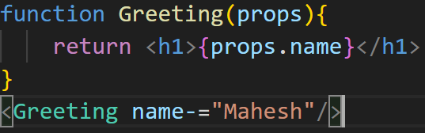
This makes your app more predictable and easier to debug.
5. React Hooks (Modern react)
React introduced Hooks like useState, useEffect, etc., to allow functional components to manage state and side effects.
Q.3: What are the advantages of using React.js in web development?
Ans: 1. Component-based architecture:
- Breaks UI into reusable, independent components.
- Makes code easier to read, test and maintain.
- Encourage modular development.
2. Virtual DOM for Hight performance:
- React uses virtual DOM to minimize direct DOM updates.
- It updates only the changed parts, making UI fast and efficient.
- Great for apps with frequent data changes (ex: dashboards, social apps).
3. Declarative UI:
- React lets you what the UI should look like based on the state.
- React handling rendering and updating.
- This makes your code clean, predictable and bug-free.
4. Reusable and maintainable code:
- You can reuse components across multiple parts of your app or in other projects.
- Helps reduce code duplication and improves maintainability.
5. Rich Ecosystem and community:
- Huge community supports, thousands of tutorials and tools.
- Easy integration with libraries like:
  - React Router (for navigation).
  - Redux / Context API (for state management).
  - Axios/ Fetch (for API calls).
  - Styled/components or tailwind CSS.
6. JSX Syntax:
- Combines HTML + JavaScript into one file.
- Makes the code more readable and expressive.
- Easier to visualize UI components.
7. Unidirectional Data flow:
- React follows one-way data binding, meaning data flows from parent to child.
- Helps in better control and debugging of data flow and UI updates.
8. React Hooks:
- React offer build-in hooks (useState, useEffect, ect.) for managing state and side effects in functional components.
- Eliminates the need for class components in most cases.
9. Strong Backing & Lon-term Support:
- Maintained by Meta (Facebook) with regular updates and improvements.
- Used by top companies (Instagram, Netflix, Airbnb, etc.) making it a future choice.
10. Cross-platform development:
- React native allows code-sharing for mobile apps (Android & IOS) using the same react knowledge
- Build progressive web apps and native apps from one database.
=>JSX (JavaScript to XML)
Q.1: What is JSX in React.js? Why is it used?
Ans:
- JSX stans for JavaScript XML.
- JSX allow us to write HTML in React.
- JSX makes easier to write and add HTML in React.
- JSX allow us to write HTML elements in JavaScript and place them in the DOM without any createElement() and/or appendChild() methods.
- JSX convert HTML tags into react elements.
- Expression of JSX:
  - With JSX you can write expressions inside curly braces {}.
- Why it is used?
Purpose | Explanation
More readable code | HTML-like syntax is easier to understand than using React.createElement().
Combines markup + logic | You can write UI layout and logic in the same file.
Powerful Expressions | You can embed JavaScript code using {} inside JSX
Cleaner UI code | Helps breaks UI into reusable components visually.

Q.2: How is JSX different from regular JavaScript? Can you write JavaScript inside JSX?
Ans: Difference between JSZ and regular JavaScript:

Feature | JSX | Regular JavaScript
Syntax | JSX allows HTML-like syntax in JavaScript | JavaScript uses only JS syntax (no HTML)
Use case | Used in React to describe UI components | Used for logic, functions, Dom manipulation, etc.
Compilation | Needs to be compiled to JavaScript | Runs directly in JavaScript engines
Readability | More readable for UI structure | UI must be created using DOM APIs or templates.

Can you write JavaScript in JSX?
- Yes, you can write JavaScript expressions inside JSX using curly braces {}.
- But you cannot write statements like if, for, while directly inside JSX, instead use conditional (Ternary) expressions or do logic before the JSX:
Example:

const isLoggedIn = true;
const element= <h1> {isLoggedIn ? “Welcome!” : “Please log in”}</h1>;
Q.3: Discuss the importance of using curly braces {} in JSX expressions.
Ans: Using curly braces {} in JSX is very important because they act as bridge between HTML-like syntax and JavaScript.
Importance of curly braces {} in JSX:
- To Embed JavaScript expressions:
- Curly braces allow you to insert dynamic content inside JSX.
- Any valid JavaScript expression can be used.
- Example:

const name=”Mahesh”;
const element=<h1>Hello, {name}!</h1>;
- To make components Dynamic:
- Curly braces let you create interactive and data-driven UIs.
- You can change values on the fly based on props, state, or conditions.
- Example:

const isLoggedIn = true;
const element= <h1> {isLoggedIn ? “Welcome!” : “Please log in”}</h1>;
- To run inline logic:
- You can include short logic such as formatting, math or conditional rendering.
- Example:

const price= 100;
return <p>Total price: {price*1.18} </p>; // add 18* GST
- To call functions:
- Useful for calling functions that return a value.
- Example:
Function getGreeting(user){
return `Hello, ${user.name}`;
}

return <h1>{ getGreeting ({name: “Mahesh”})}</h1>;

=> Components (Functional & Class Components):
Q.1: What are components in React? Explain the difference between functional components and class components.
Ans:
- Components are independent and reusable bits of code. They serve the same purpose as JavaScript functions, but work in isolation and return HTML.
- Components come in two types, Class components and Function components, in this tutorial we will concentrate on Function components.
- In older React code bases, you may find class components primarily used. It is now suggested to use Function components along with Hooks, which were added in React 16.8. There is an optional section on Class component for your reference.

- Difference between class and functional component:
Features | Functional Component | Class Component
State Management | It can use Hooks like useState, useReducer. | It uses this.state and this.setState()
Lifecycle Methods | It uses useEffect  Hook for lifecycle methods | It uses traditional lifecycle methods like componentDidMount, componentWillUnmount
Rendering | Returns JSX directly inside the function | Uses a render() method to return JSX
Performance | Faster and more lightweight due to simpler structure | Slightly heavier due to the overhead of class instances
Hooks | Can use React hooks (useState, useEffect, etc.) | Cannot use hooks; relies on lifecycle methods and state
This Keyword | Does not use this keyword | Uses this to access props and state
Code Complexity | Less boilerplate code, easier to write and understand | More boilerplate code, especially for state and methods
Event Handling | Simple and direct event handling | Requires method binding for event handling

Q.2: How do you pass data to a component using props?
Ans:
React components use props to communicate with each other. Every parent component can pass some information to its child components by giving them props. Props might remind you of HTML attributes, but you can pass any JavaScript value through them, including objects, arrays, and functions.
- Passing Data to a Component using props:

Step 1: Pass props to a child component.
Example:
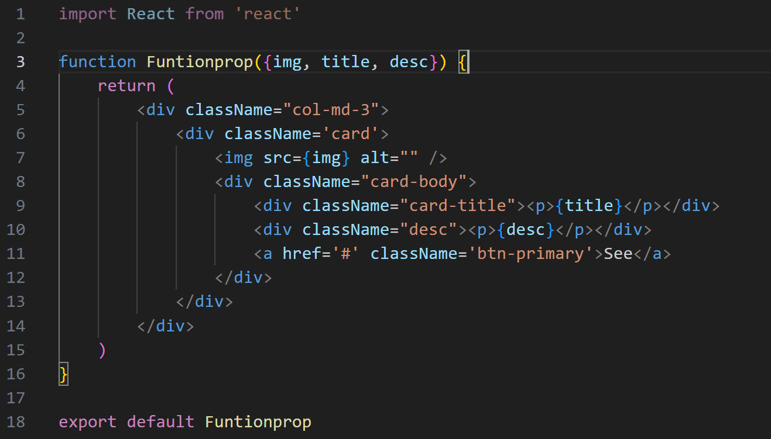

Step 2: Read props inside the child component.
Example:
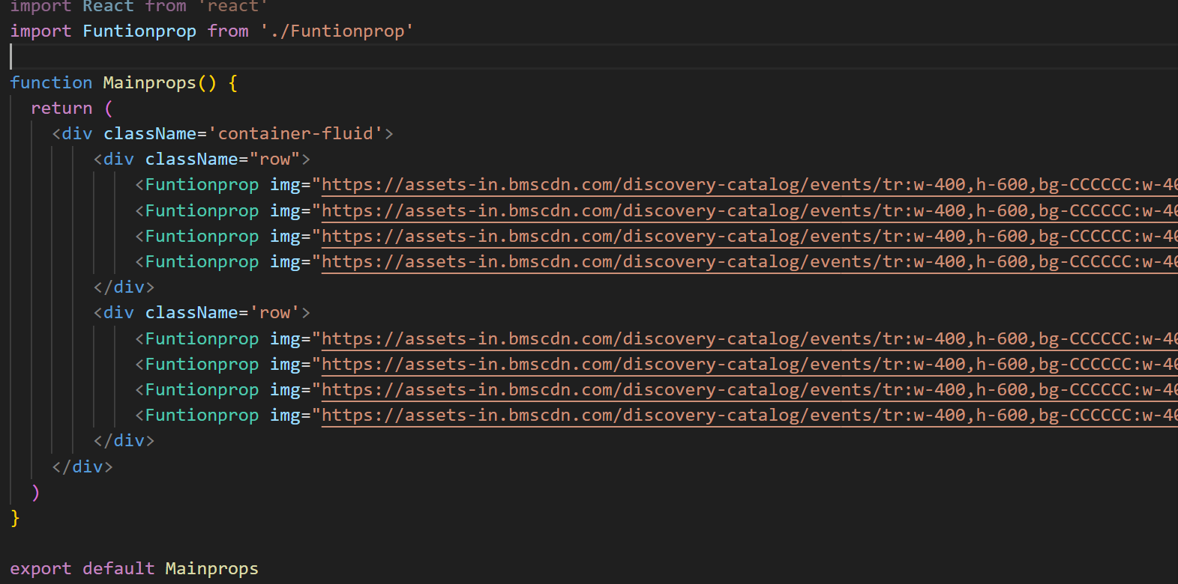
Q.3: What is the role of render() in class components?
Ans: In React class components play an important role in building robust and scalable applications. In the class component render method is used for rendering user interface elements on the screen.
In class components, React expects the UI to be returned from a specific method.
That method is always called render().

=> Props And State:
Q.1: What are props in React.js? How are props different from state?
Ans: props stands for properties. Props is special keywords in React like properties/parameter/argument Props are arguments passed into React components. Props are passed to components via HTML attributes.
React Props are like function arguments in JavaScript and attributes in HTML. To send props into a component, use the same syntax as HTML attributes:
Props and state are both used to store data in React, but they have different purposes and behavior.

Feature | Props | State
Definition | Data passed to a component (inputs). | Data managed inside a Component.
Who sets it? | Parent Component. | The Component itself.
Can it can be changed | Read only. | Can be updated.
How to update it? | Cannot be update by component | useState() in functional component and this.setState() in class component.
Purpose | Pass Date parent to child | Track Dynamic data / UI change.
Accessible through | Props | State.

Q.2: Explain the concept of state in React and how it is used to manage component data.
Ans: React components have a built-in state object. State in React functional components refers to a way of managing data that influences the rendering and behavior of components. Unlike class components, where state is managed using a this.state object, functional components use the React Hook useState to manage state efficiently. State is mutable, it can be change as per the need. When the state object changes, the component re-renders. The state object is where you store property values that belong to the component so only accessible inside the component.
- State is Local to the Component: Each component has its own state, which is independent of other components.
- Reactivity: When the state changes, React re-renders the component to reflect the updated state in the UI.

- State is Immutable: You should never directly modify the state. Instead, you use functions to update it.

- State is Managed with Hooks: In functional components, the useState hook is used to manage state.

- How State is used to manage Component data:
State is used to manage component data by storing values inside the component and updating them whenever something changes (like a user action).
When state changes, React automatically re-renders the component so the UI always shows the latest data.
Example:
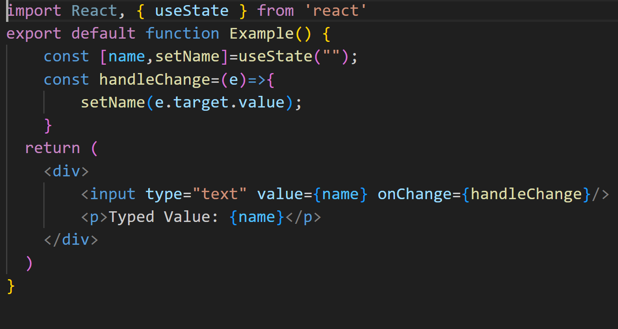

Q.3: Why is this.setState() used in class components, and how does it work?
Ans: this.setState() is used because it’s the proper way to change state in class components and allows React to re-render the component when the state changes.
How does it work:
- Triggers Re-render: When setState() is called, React schedules an update to the component’s state and triggers a re-render. The updated state is reflected in the component’s output.

- Merging States: setState() merges the new state with the current state. This is especially useful when you only want to update part of the state, leaving other properties intact.

- Asynchronous Updates: setState() updates the state asynchronously, meaning the changes don't happen immediately. React batches the updates for performance reasons, and the re-render will happen once all the updates have been processed.

Example:
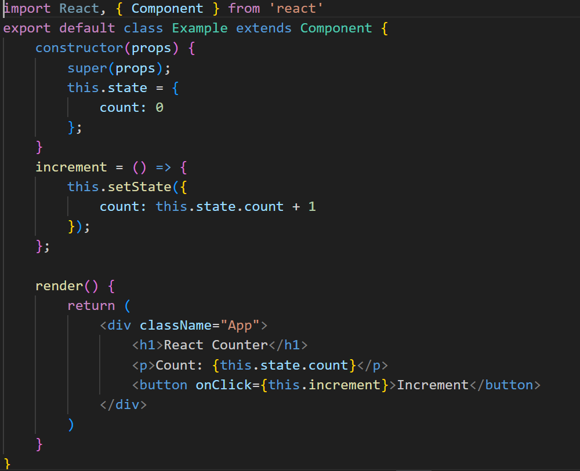

=> Handling Events in React:
Q.1: How are events handled in React compared to vanilla JavaScript? Explain the concept of synthetic events.
Ans:
Feature | Vanilla JavaScript | React (JSX)
Event Name | Lowercase- onclick, onchange etc. | camelCase- onClick, onChange etc.
Event Handler | String or function reference. | Function reference only.
Binding | Not needed. | Class methods usually need to be bound to this.
Example | <button onclick=”handleClick()”>Click </button> | <button onclick={ handleClick()}>Click </button>

- Synthetic Events:
- Synthetic events in React are cross-browser wrappers around the browser's original event.
- Different browsers may have different names for the events. They create a uniform interface that React uses to ensure that events execute consistently across browsers.
- React normalizes this information to provide a consistent API for handling events regardless of the browser.
- React uses its own event system called Synthetic Events.
- SyntheticEvent is a wrapper around the browser’s native events.
- It has the same interface (so you can use e.target, e.preventDefault(), etc.), but React uses it internally to make event handling:
- work the same across all browsers (cross-browser compatibility).
- be more efficient via event delegation.
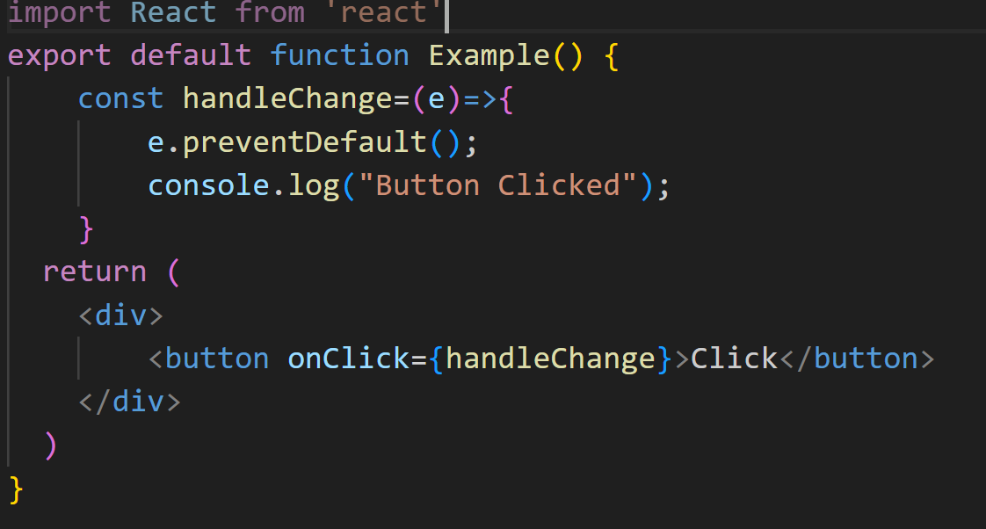
- Here, e is a SyntheticEvent (not the raw DOM event), but it behaves in the same way.
Q.2: What are some common event handlers in React.js? Provide examples of onClick, onChange, and onSubmit.
Ans: Some common event handlers in React.js:
Events | Description
onClick | Fires when an element is clicked.
onChange | Fires when input value changes.
onSubmit | Fires when a form is submitted.
onMouseOver | Fires when the mouse hovers.
onKeyDown | Fires when a key is pressed.

Examples:
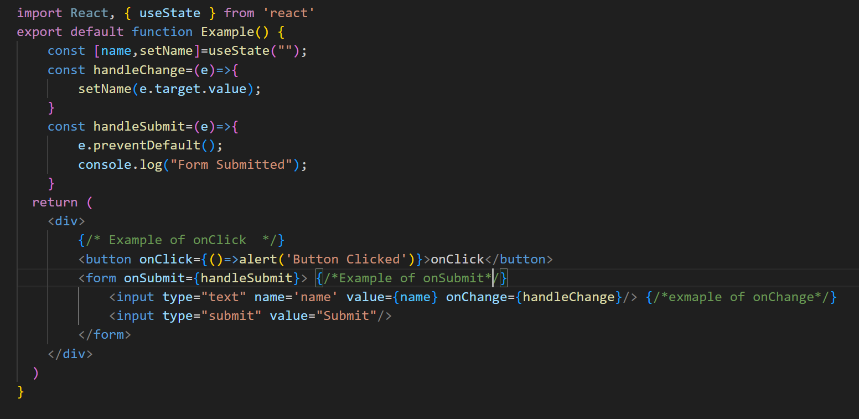

Q.3: Why do you need to bind event handlers in class components?
Ans:
- In class components, you need to bind event handlers so that the this keyword inside the handler refers to the component instance.
- By default, JavaScript class methods are not bound to the class instance.
So when a method (like handleClick) is used as an event handler, this becomes undefined, and you can’t access this.state or this.props.
- That’s why we use. bind(this) in the constructor, or use arrow functions.
- In short, in class components, event handlers need to be bound to this so that you can access the component’s state and props inside those handlers.

=> Conditional Rendering:
Q.1: What is conditional rendering in React? How can you conditionally render elements in a React component?
Ans: Conditional rendering allows dynamic control over which UI elements or content are displayed based on specific conditions. It is commonly used in programming to show or hide elements depending on user input, data states, or system status. This technique improves user experience by ensuring that only relevant information is presented at a given time. It enables components to display different outputs depending on states or props. This ensures that the UI updates dynamically based on logic instead of manually manipulating the DOM.
=> How can you conditionally render elements in a React component?
1. Using if / else:
If/else statements allow rendering different components based on conditions. This approach is useful for complex conditions.
